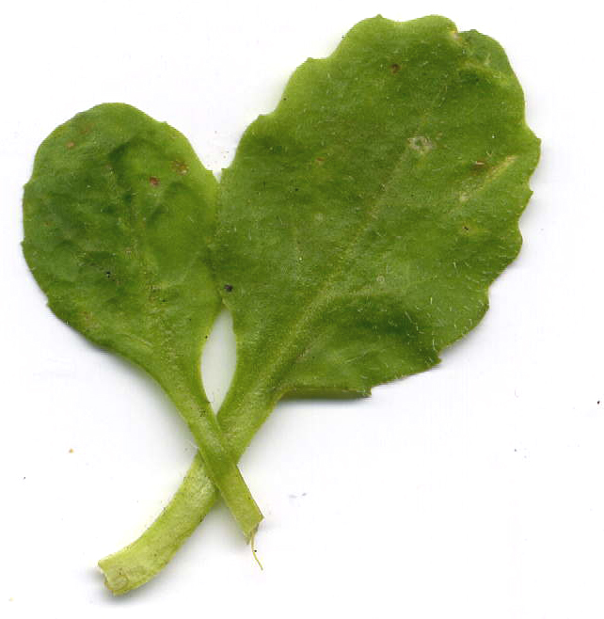
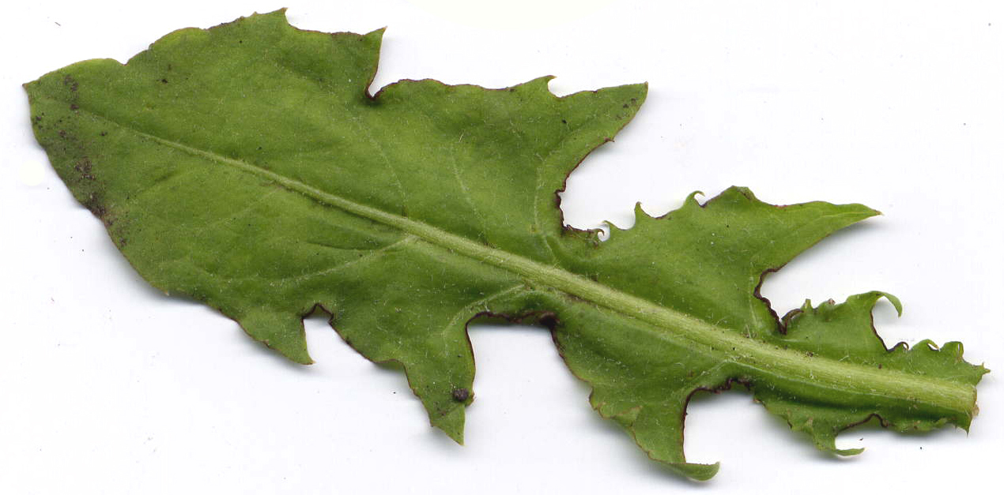
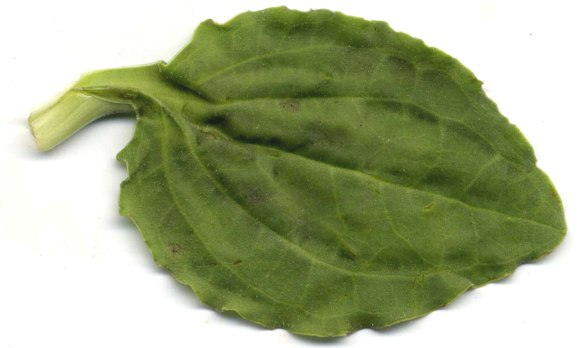
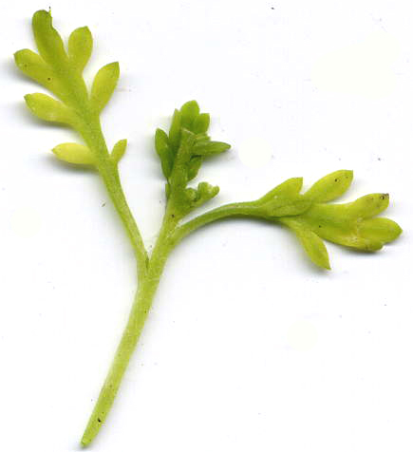
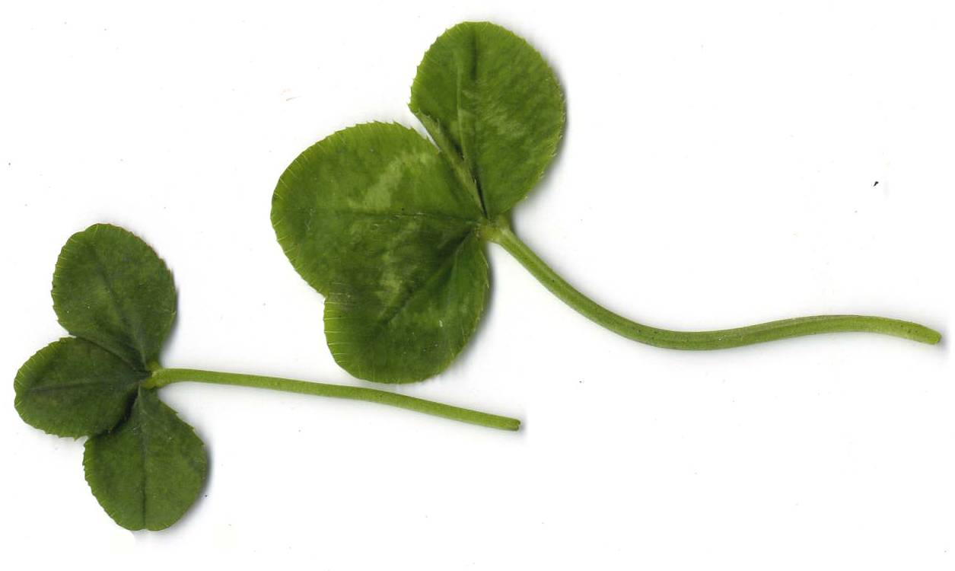
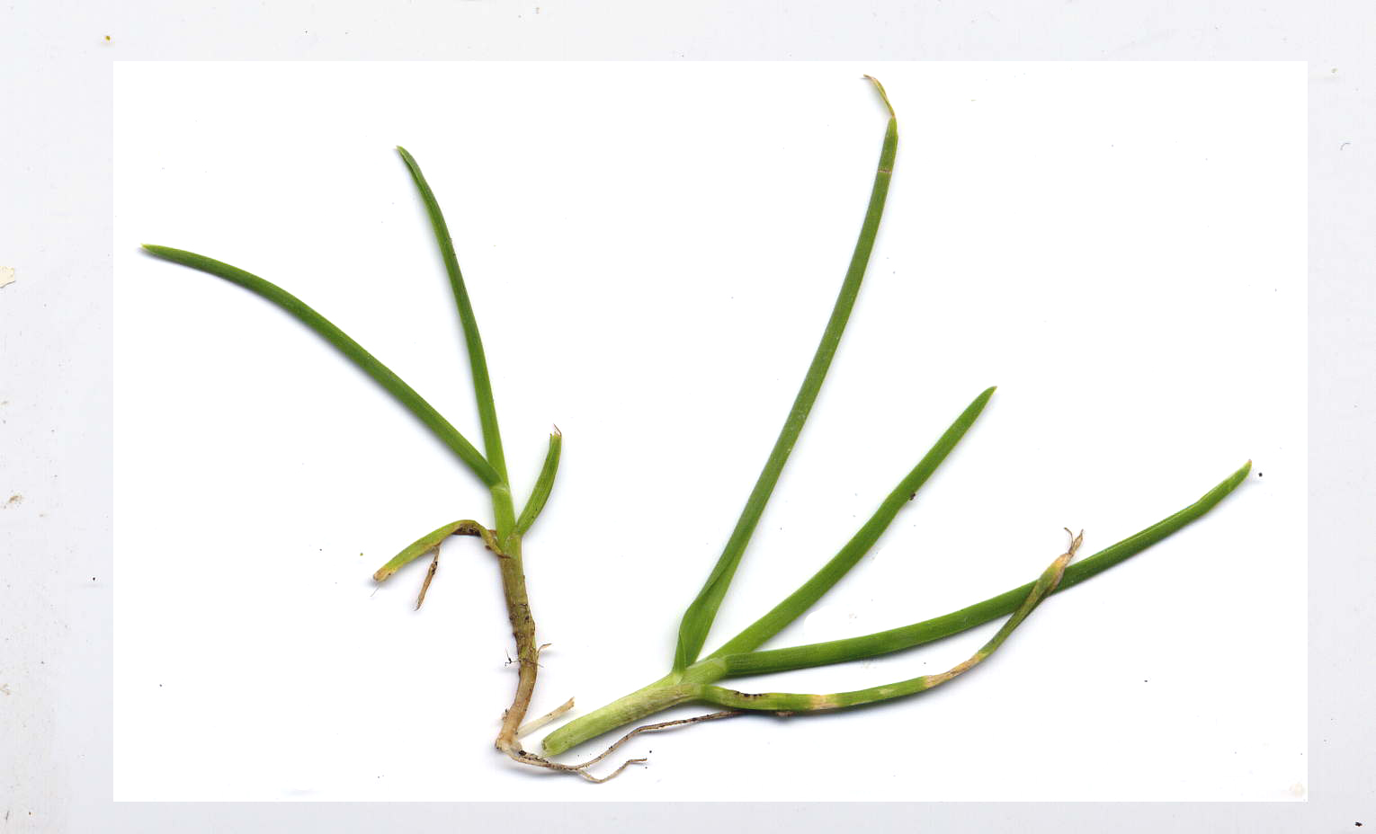
Lawn survey - Identification and recording table 2 - Frequency
Scan of plant | Name | Present | Absent
Daisy
Bellis perennis
Dandelion
Taraxacum section Ruderale
Lesser Swine-cress
Coronopus didymus
Greater Plantain
Plantago major
White Clover
Trifolium repens
Perennial Rye-grass
Lolium perenne
Tick the present or absent column for each species

